**CHAPTER 1**

**INTRODUCTION**

### 1. INTRODUCTION TO PROJECT

Internet of Things (IoT) is widely used in connecting devices and collecting data information. Internet of Things is used with IoT frameworks to handle and interact with data and information. In the system users can register their sensors, create streams of data and process information. IoT are applicable in various methodologies of agriculture. Applications of IoT are Smart Cities, Smart Environment, Smart Water, Smart Metering, Security and

Emergency, Industrial Control, Smart Agriculture, Home Automation, e-Health etc. ‘Internet of Things’ is based on device which is capable of analysing the sensed information and then transmitting it to the user.

Measuring soil moisture is important in agriculture to help farmers manage their irrigation systems more efficiently. Not only are farmers able to generally use less water to grow a crop, they are able to increase yields and the quality of the crop by better management of soil moisture during critical plant growth stages. Embedded system for automatic irrigation of an agriculture field offers a potential solution to support site- specific irrigation management that allows producers to maximize their productivity while saving the water.

* + The proposed technique has many advantages like Reducing the risk of

electric shocks, deaths due to poisonous creatures in the fields.

* + Visual display using LCD display unit.
  + Watering depends on the moisture level present in the field.
  + All the farm parameters can view through online in graphical notation.
  + Efficient and low cost design.
  + Fast response.
  + User friendly.

* 1. **Aim**

The Smart Agriculture project aims to improve the skills and competences of people in the agricultural sector by introducing a training program which will help to improve the quality product of crops without any prediction.

* 1. **Objectives**

The main objectives of the Smart Agriculture project are to highlight:

* The reasons for why the production and marketing of the superfoods is an alternative beneficial option for the bio-producers.
* Their competitive advantages compared to other bio-products.

**1.3 Problem Statement**

This is the project from the motivation of the farmers working in the farm lands are solely dependent on the rains and bore wells for irrigation of their land. In recent times, the farmers have been using irrigation technique through the manual control in which the farmers irrigate the land at regular intervals by turning the water-pump ON/OFF when required. Moreover, for the power indication they are glowing a single bulb between any one of phase and neutral, meanwhile when there is any phase deduction occurs in other phases, the farmer cannot know their supply is low. If they Switch ON any of the motor, there will be the sudden defuse in motor circuit. They may have to travel so far for SWITCHING ON/OFF the motor. They may be suffering from hot Sun, rain and night time too. After reaching their farm, they found that there is no power, so they quietly disappointed to it!! Is there any solution for it???

We know that Indian economy is mostly depends on agriculture but the farmer who produce crops are living a poverty life and are not able to feed their family as they are considered as the god but they itself are living a beggar life. Due to which sometimes they do suicide by getting flustered from their life.

This is due to the fact that they are not able to grow quality crops and their values in the market is low because they do not provide required material to crop at the time due to which it get destroyed because of prediction.

The prediction include such as watering or pouring water to plant or soil which get wrong mostly and because of this the problem arises.

###### 1.3.1 BLOCK DIAGRAM:

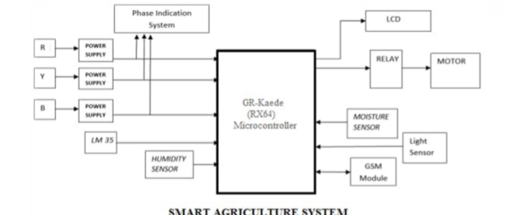

Figure 1:- Block diagram of smart agriculture

**1.4 Background of the Project (Literature Survey)**

Smart agriculture monitoring system has been focus in the research community in the recent years. This monitoring systems can be classified according to the environment that is used for, such as industrial, home, office, agriculture and others environment. In literature system, this smart agriculture monitoring system project will be discussed among the previous research of a project. There are five selected research papers has been chosen from the previous project as literature review to identify the differences of this project. Table 1 shows the critical review on developed system. The entire previous projects are user friendly because this system actually used to monitor a specific area. However, this smart agriculture monitoring system is low cost and low power consumption project because it causes no hazardous harm in the environment and it is more reliable system.

|  |  |  |  |  |  |  |
| --- | --- | --- | --- | --- | --- | --- |
| **S.No** | **Functionality** | **[1]** | **[2]** | **[3]** | **[4]** | **[5]** |
| **1** | User Friendly | Yes | Yes | Yes | Yes | Yes |
| **2** | Low Cost | Yes | Yes | No | No | No |
| **3** | Application [Mobility] | Yes | Yes | WSN | WSN | Sensor |
| **4** | Power | Yes | LOW | Low | Low | Low |
| **5** | Employ | Home  Control | Agriculture Industry | Agriculture Industry | Agriculture Industry | Agriculture Industry |
| **6** | User Interface | Yes | - | Yes | Yes | Yes |
| **7** | Security | Yes | - | Yes | Yes | - |
| **8** | Load Limit [web server] | Yes | Yes | Yes | Yes | No |
| **9** | Simplicity | Yes | - | No | No | Yes |
| **10** | Flexibility | Yes | Yes | Yes | Yes | Yes |
| **11** | Community | Yes | Yes | Yes | Yes | No |
| **12** | Freedom | Yes | Yes | Yes | Yes | Yes |
| **13** | Easy installation & Upgrade | Yes | Yes | No | Yes | Yes |
| **14** | Display control | Yes | - | Yes | Yes | Yes |
| **15** | Configure Website | Yes | Yes | Yes | Yes | No |

Table 1. Critical Survey on development system

**1.4.1 COMPARISON STUDY**

From the paper had been researched, there are few methods for agriculture monitoring system that suitable for new Android Development such as using GSM, CCTV system and other more. Table 2 are the list and the few advantages and disadvantages from the previous researches.

|  |  |  |  |
| --- | --- | --- | --- |
| **S.No** | **Papers** | **Advantages** | **Disadvantages** |
| 1 | Internet of Things:  Ubiquitous Home  Control and Monitoring  System using Android based Smart Phone | The system does not require a dedicated server PC and offers a novel  communication protocol to monitor and control the home environment  with more than just the switching  functionality | The system is only use to controlling devices  and appliances remotely  by using android smart  phone |
| 2 | Internet of Things  (I.O.Ts): A vision, architectural elements, and future directions | A framework enabled by a scalable cloud to provide the capacity to utilize the IOT. The framework allows networking. | The evolution of the next generation mobile  system will depend on the creativity of the  users in designing new applications. |
| 3 | Study on an Agricultural  Environment Monitoring  Server System using Wireless Sensor Networks. | The system could monitor the environmental information on the  outdoors remotely, and by the decision making of crop producers through analysis of the collected information. | The system required a  CCTV to monitor a realtime video and wifi module to transfer information. |
| 4 | A Wi-Fi based Smart  Wireless Sensor  Network for Monitoring an Agricultural  Environment | The capability to document and detail changes in parameters of interest has become increasingly valuable. | The WSN802G modules was been used as a nodes to send data  wirelessly to a central server, which collects the data, stores it and  allows it to be analyzed and displayed as needed. |
| 5 | Data Acquisition of  Greenhouse Using Arduino | There are multiple sensors which is used for simulation or processing to achieve the better enhancement of growth in greenhouse. | A Graphical User  Interfaces (GUI) had been used in these  system through Lab  VIEW |

Table 2: Comparison Study of Human Notification System

**1.5 Software Requirements**

An Open Software Enterprise should:

* provide the actual (cloud) infrastructure to make the ecosystem possible;
* orchestrate the whole collaboration process and resolve possible disputes;
* be neutral toward the other Actors in the ecosystem or at least transparent in case they also participate as provider of services and/or ICT Components;
* not be dominated by a single organization;
* manage the platform in such a way that it is affordable for SMEs to participate;
* ensure that Application Components are developed according to the Platform Architecture (e.g. a service-oriented architecture) to facilitate configuration and collaboration;
* ensure that Application Components contain an description to enable the use of it in various configurations;
* ensure that the data shared between Application Components are tagged.

**1.5.1 Basic design of a Fully Automated Farming Software Ecosystem reference architecture.**

|  |  |  |  |
| --- | --- | --- | --- |
| **Componentsof the Fully Automated Farming** | **Sub-Components** | **Partof AgroSense** | **Part of Crop-R** |
| Open Software Enterprise | Open Software  Enterprise structure | Yes | Yes |
|  | A partnership model/Actor model | No | Yes |
|  | IP Strategy  Documentation | Yes | No |
|  | Technology Vision | Yes | Yes |
|  | Technology research vision | Yes | Yes |
|  | Technical Architecture Documentation | Yes | Yes |
|  | Farm Information Model - | | - |
|  | Actor Model Yes | | No |
|  |  | |  |

|  |  |  |  |  |
| --- | --- | --- | --- | --- |
|  | Business Control Models No | Yes | |  |
|  | Business Process Model | | No | No |
|  | Data Model | | Yes | Yes |
|  | Application  Programming Interface | | Yes | Yes |
|  | Collaborative tools | | Yes | Yes |
|  | Configuration Support documentation | | No | No |
| Actors | Orchestrator Role | | Yes | Yes |
|  | Niche Player Role | | Yes | Yes |
|  | External Actor Role | | Yes | Yes |
|  | Vendor/Value Added Reseller Role | | Yes | Yes |
|  | End-User/Customer Role | | Yes | Yes |
|  | Software Vendor Role | | Yes | Yes |
|  | Agriculture Service Provider Role | | Yes | Yes |
|  | Infrastructure Provider Role | | Yes | Yes |
|  | Customer/End-User | | Yes | Yes |
| Business Services | Business Services Offered | | Yes | Yes |
| Platform | Operating System | | Yes | Yes |
|  | Orchestration Module | | Partly | No |
|  | System and Data integration module | | Yes | Yes |
|  | Security Privacy Trust  Framework | | Yes | Yes |
|  | Development Kit | | Yes | No |

**Table 3. Mapping of the Smart agriculture Software Ecosystem reference architecture components and sub-components on the Smart Agriculture Software Ecosystems Crop-R and AgroSense.**

**1.5.1.1 High-level description of the reference architecture The architecture comprises five main components:**

* Actors,
* Platform,
* Open Software Enterprise,
* Business Services and
* ICT Components. Actors provide or use ICT Components and Business Services.

The Platform includes ICT Components for End-Users. The relation between the Actors and the Platform is managed by the Open Software Enterprise (organization). The following subsections will describe various components of the design in more detail.

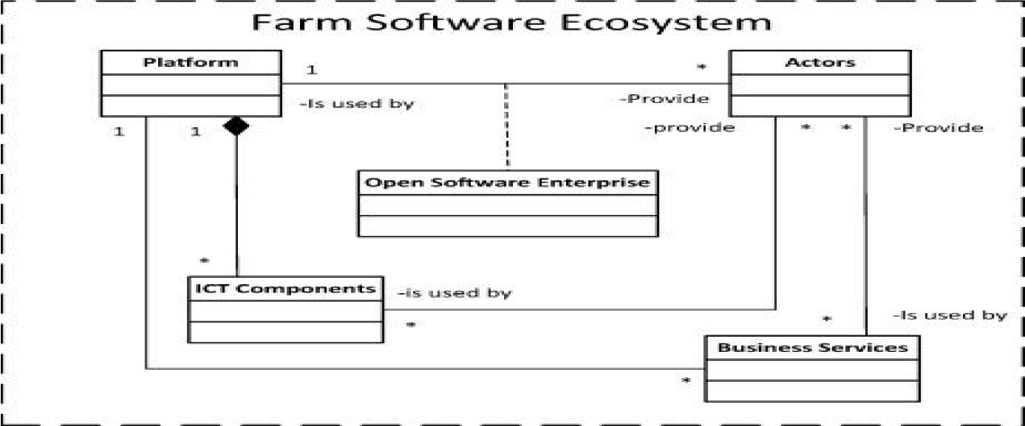

Figure 2: High-level view of the Farm Software Ecosystem reference architecture.

**1.5.1.2 Platform**

A platform is a set of stable components that supports diversity and evolution in a system by constraining the linkages among the other components. These components are integrated and work as an integrated system. These components include software and service modules, along with an architecture that specifies how they fit together. A Platform used within Farm Software Ecosystems must be able to support four Actor roles which are; end-users (e.g. farmers, contractors), software vendors/developer (e.g. app developer), agricultural services providers (e.g. a configurator of different systems) and the Platform orchestrator that among others runs the Platform. With such a Platform a configurator should be enabled to configure an ICT Component for a farmer using Application Components of multiple vendors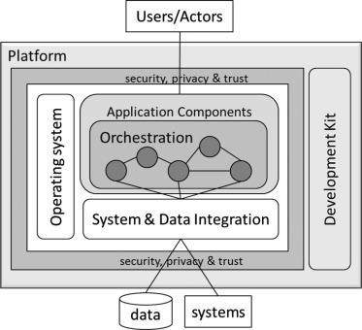

Figure 3: Basic architecture of a platform for a Farm Software Ecosystem.

**1.5.1.3 There the software that is used in implementation testing and designing of project are:**

* Raspberry Pie
* Android Studio

**Raspberry Pie** :- he Raspberry Pi is a series of small single-board computers developed in the United Kingdom by the Raspberry Pi Foundation to promote teaching of basic computer science in schools and in developing countries. The original model became far more popular than anticipated, selling outside its target market for uses such as robotics. It does not include peripherals (such as keyboards and mice) and cases. However, some accessories have been included in several official and unofficial bundles.

The organisation behind the Raspberry Pi consists of two arms. The first two models were developed by the Raspberry Pi Foundation. After the Pi Model B was released, the Foundation set up Raspberry Pi Trading, with Eben Upton as CEO, to develop the third model, the B+. Raspberry Pi Trading is responsible for developing the technology while the Foundation is an educational charity to promote the teaching of basic computer science in schools and in developing countries.

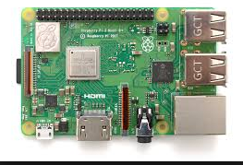

Figure 4: Raspberry Pie

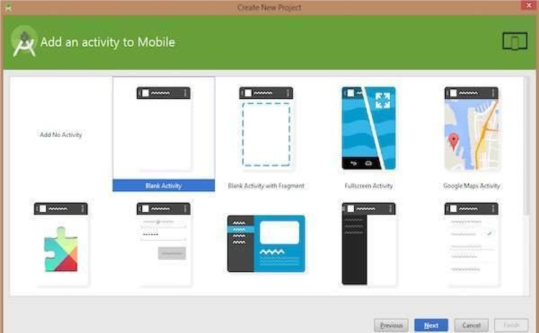

Figure 7: Ardroid studio

* 1. **Hardware Requirements**

* DHT 11 Temperature & Humidity sensor
* Jumper Wires
* DC motors
* Soil moisture Sensor
* 5v Relay Module
* Smoke sanser

**1.6.1 DHT 11 Temperature & Humidity Sensor:** This DHT11 Temperature and Humidity Sensor features a calibrated digital signal output with the temperature and humidity sensor complex. Its technology ensures the high reliability and excellent long-term stability. A highperformance 8-bit microcontroller is connected. This sensor includes a resistive element and a sense of wet NTC temperature measuring devices. It has excellent quality, fast response, anti-interference ability and high cost performance advantages.

Each DHT11 sensors features extremely accurate calibration of humidity calibration chamber. The calibration coefficients stored in the OTP program memory, internal sensors detect signals in the process, we should call these calibration coefficients. The single-wire serial interface system is integrated to become quick and easy. Small size, low power, signal transmission distance up to 20 meters, making it a variety of applications and even the most demanding applications. The product is 4-pin single row pin package. Convenient connection, special packages can be provided according to users need.

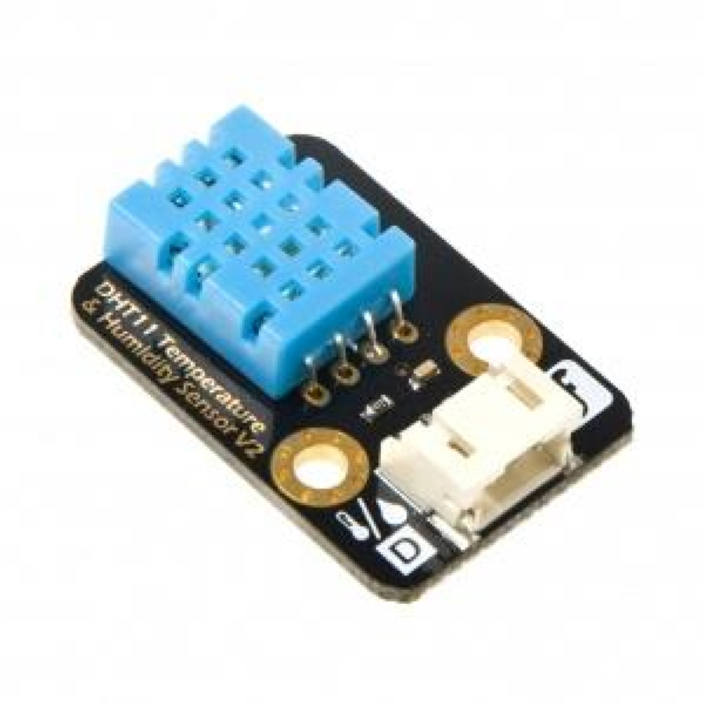

**Figure 9: DHT 11 sensor**

**1.6.2 Jumper Wires:** A jump wire (also known as jumper, jumper wire, jumper cable, DuPont wire, or DuPont cable – named for one manufacturer of them) is an electrical wire or group of them in a cable with a connector or pin at each end (or sometimes without them – simply "tinned"), which is normally used to interconnect the components of a breadboard or other prototype or test circuit, internally or with other equipment or components, without soldering.

Individual jump wires are fitted by inserting their "end connectors" into the slots provided in a breadboard, the header connector of a circuit board, or a piece of test equipment.

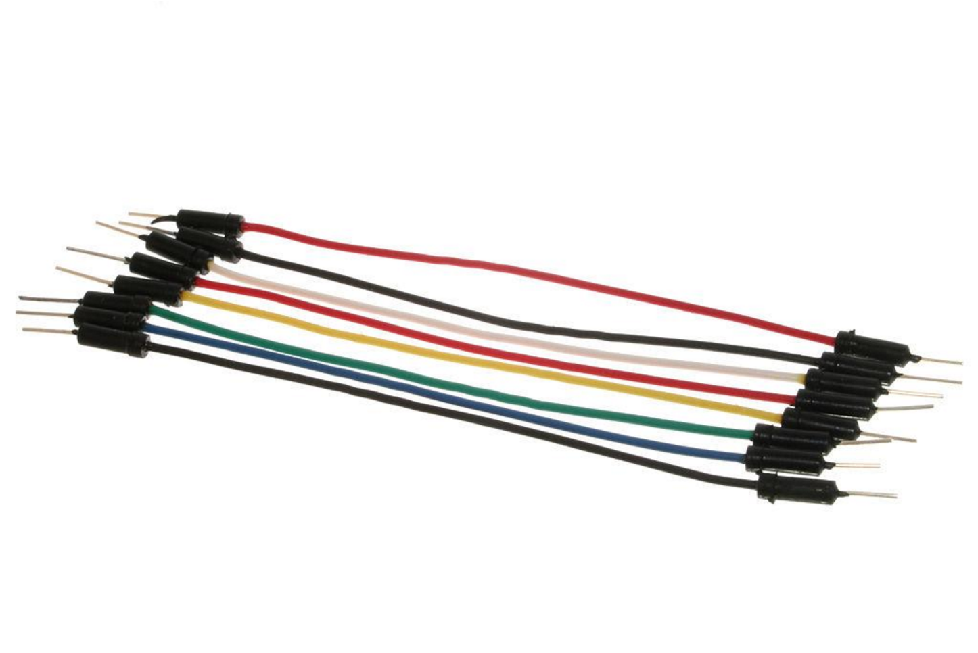

**Figure 10: Jumper Wires**

**1.6.3 Dc Motor**:- A DC motor is any of a class of rotary electrical machines that converts direct current electrical energy into mechanical energy. The most common types rely on the forces produced by magnetic fields. Nearly all types of DC motors have some internal mechanism, either electromechanical or electronic, to periodically change the direction of current flow in part of the motor.

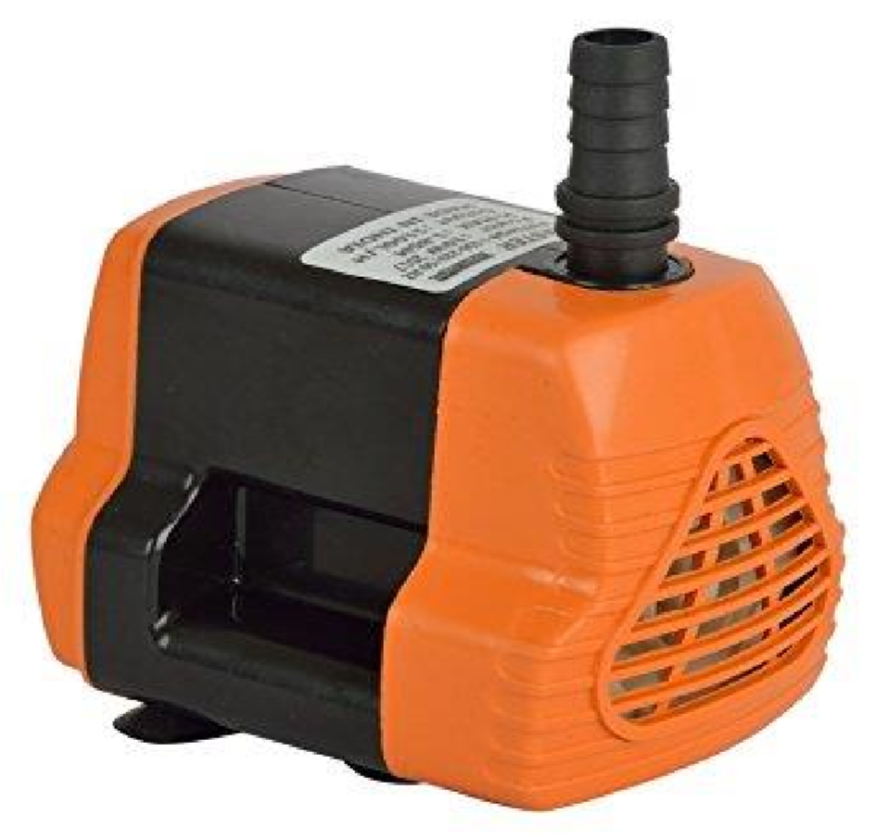

**Figure 11: Water motor**

**1.6.4 Soil Moisture Sensor**:- Soil moisture sensors measure the volumetric water content in soil. Since the direct gravimetric measurement of free soil moisture requires removing, drying, and weighting of a sample, soil moisture sensors measure the volumetric water content indirectly by using some other property of the soil, such as electrical resistance, dielectric constant, or interaction with neutrons, as a proxy for the moisture content. The relation between the measured property and soil moisture must be calibrated and may vary depending on environmental factors such as soil type, temperature, or electric conductivity. Reflected microwave radiation is affected by the soil moisture and is used for remote sensing in hydrology and agriculture. Portable probe instruments can be used by farmers or gardeners.

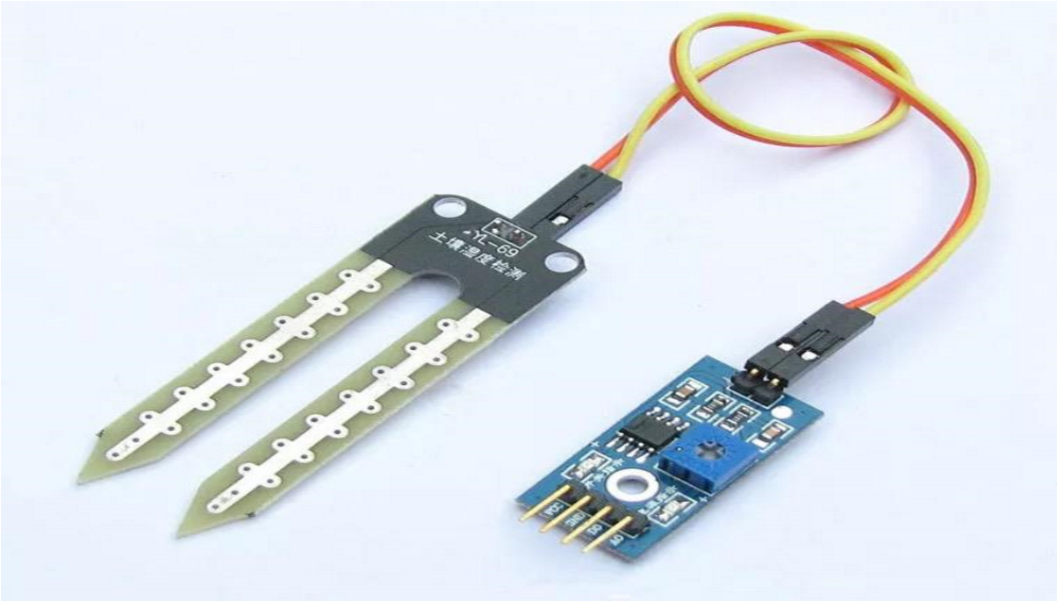

**Figure 12: Soil Moisture Sensor**

**1.6.5 Relay:-** A relay is a type of a switch that acts as an interface between microcontrollers and AC Loads.

A simple Single Pole – Single Throw (SPST) relay, like the one used in this project consists of 5 Terminals: 5V, GND, Normally Open (NO), Normally Close (NC) and Common

(COMM). Since we need to control this relay with the help of Arduino, a transistor is used with an additional pin called Control Pin on the Relay Module.

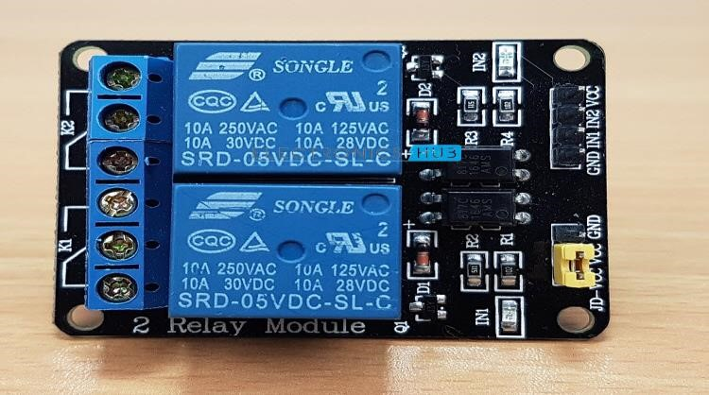

**Figure 13: Relay Board**

**CHAPTER 2**

**PRODUCT BACKLOG**

1. **PRODUCT Backlog I**

In the Product backlog include all the software requirement to the basis of contain the sustainability of agriculture field. The agriculture system include the strategies of the agriculture. Agriculture field requirement to login and register to a farmer. The farmer can access their profile. Farmer can see the result of their own farm. They have to select the own farm. A farmer have to select their own hardware to select the connected device. Thus the according farmer can according to their own schedule task. The farmer have to select the own builder. The own farmer builder to extract the embedded system. The system have requirement to broker to change the price according to their quality assurance. To ahead the system of requirement to absolute to change the fixed to change the fixed price. The system on to take the process. The chapter is relevant to take the task is achieved. To connection the profile to determine the ethics to be change. The things have to design to accumulate data. In the product backlog. The product have schedule task with the acknowledge with the system. In the product backlog the system requirement have to change the profile with the portfolio acknowledge to the system to the sprint backlog in the system. The portfolio in the system to the drain the system with the requirement process. The design is to fill the systematic portfolio of design. The graphic user interface diagram is used to connect the wifi server with the face structure.

The two graphs is shown the system technique to be design the part of the system. The temperature and humidity sensors are used shown the real time data with the acknowledge of water the system to schedule task. The temperature and humidity is the required source of soil. In the soil temperature is taken from the soil. The soil is fixed with the schedule task to be given in the system. The portfolio in the system to the drain the system with the requirement process. The design is to fill the systematic portfolio of design. The graphic user interface diagram is used to connect the wifi server with the structure.

|  |  |  |  |  |
| --- | --- | --- | --- | --- |
| **SPRINT**  **BACKLOG** | **US ID** | **BACKLOG ITEM** | | |
| **AS A/AN** | **I WANT TO** | **SO THAT** |
| 1 | SB1/US1 | Farmer | Register farmer into application | they have registered to application for use |
| 1 | SB1/US2 | Farmer | Login Into the application | to control the hardware or make changes |
| 1 | SB1/US3 | Farmer | View current temp. | See The Temp |
| 1 | SB1/US4 | Farmer | View the humidity | see the mositure of my farm |
| 1 | SB1/US5 | Farmer | Provide the controling button | the hardware can be controlled from website even in during long distance |
| 1 | SB1/US6 | Farmer | show the complete information of agriculture | the farmer can be aware of the condition of farm and crops |
| 1 | SB1/US7 | Farmer | formation of graph | show data in the form of graph in increasing or decreasing order |
| 1 | SB1/US8 | Farmer | update the temp. after every 5 minute | temperature change can be see |
| 1 | SB1/US9 | Farmer | view the unauthorized person/creature | security is providing to farm |
| 1 | SB1/US10 | Farmer | irrigation of agriculture | when to provide water to crops |
| 1 | SB1/US11 | Farmer | provide alarm as a security | than alarm is propagated |
| 1 | SB1/US12 | Farmer | Stop the alarm | alarm can be stopped using app by taking action |
| 1 | SB1/US13 | Farmer | Store the last 10 days temperature | temperature data of 10 days are stored for references |
| 1 | SB1/US14 | Farmer | Store the last 10 days of humidity | humidity data of 10 days are stored for references |
| 1 | SB1/US15 | Farmer | provide water to particular area | if temperature of are increases it provide water |
| 1 | SB1/US16 | Farmer | provide green and red led for temperature | when temp is high red led will glow and when it is in normal green will glow |
| 1 | SB1/US17 | Farmer | start irrigation system automatically when  temperature is high | all the process of irrigation system will start automatically when temp is high |
| 1 | SB1/US18 | Farmer | view the turbudity of water | what is is TDS level of water so that water of good quality is provided |
| 1 | SB1/US19 | Farmer | Water level indicator | level of water in a tank for pouring to crop |
| 1 | SB1/US20 | DBA | Fire Insert  Query (For  Registration) | I Can Insert  New Records In  The Database |
| 1 | SB1/US21 | DBA | Fire Select  Queries | I Can View The  Records |
| 1 | SB1/US22 | DBA | Fire Update  Queries | I Can Keep The  Database  Updated |
| 1 | SB1/US23 | DBA | Fire Delete  Queries | I Can Remove  Unwanted Or  Faulty Data |
| 1 | SB1/US24 | DBA | Take Backup | I Can Save The  Old Records In  The Database  For Future Use |
| 1 | SB1/US25 | DBA | Delete Backup | I Can Delete  The Records  Which Is Not  Needed Any  More |
| 2 | SB2/US26 | AGRI  OFFICER | Login Into The System phone no | I Can Access  The Digital  College System |
| 2 | SB2/US27 | AGRI  OFFICER | Modify The  Account  Password | I Can Keep My  Account Secure |
| 2 | SB2/US28 | AGRI  OFFICER | Finalize The Optional farmer list | Course  Allotment Can  Be Done |
| 2 | SB2/US29 | AGRI  OFFICER | Create Farmer account | Load Allotment  Can Be Done |
| 2 | SB2/US30 | AGRI  OFFICER | Allot The farm | Time-Table Can  Be Made |
| 2 | SB2/US31 | AGRI  OFFICER | View The monitor of farm | I Can Monitor  The Current  Schedule |
| 2 | SB2/US32 | AGRI  OFFICER | Modify The  Time Table | The Schedule  Can Be  Modified Due  To Changes |
| 2 | SB2/US33 | AGRI  OFFICER | View The  Sensor data | I Can Know  The farmer |
| 2 | SB2/US34 | AGRI  OFFICER | View The  Farmer | I Can Know  The Far mer |
| 2 | SB2/US35 | AGRI  OFFICER | View The Temprature data | I Can Keep A Check On temp.  data |
| 2 | SB2/US36 | AGRI  OFFICER | View The  Result List Of  The Students | I Can Monitor  The  Performance Of  The Farmer |
| 2 | SB2/US37 | AGRI  OFFICER | Insert dispersive data to the coordinator | I Can Keep A  Track Of  Farmer |
| 2 | SB2/US38 | AGRI  OFFICER | View  Indiscipline  Activities Of  Students | I Can Give Fair  Reading |
| 2 | SB2/US39 | AGRI  OFFICER | View The List  Of farm | I Can Plan Activities of farmer |
| 2 | SB2/US40 | AGRI  OFFICER | View The  Participation | Activeness Of  The Farm |
|  |  |  | Details Of  Activities |  |
| 2 | SB2/US41 | AGRI  OFFICER | notify to the student | Activites given to the student |
| 2 | SB2/US42 | AGRI  OFFICER | View farmer  list | The Quality Of  Notes Can Be  Reviewed |
| 2 | SB2/US43 | AGRI  OFFICER | Create Notice to the farmer | I Can Pass On  Important  Information |
| 2 | SB2/US44 | AGRI  OFFICER | View Notices to the farmer | I Can Review Or Read New  Notices |
| 2 | SB2/US45 | AGRI  OFFICER | Send Messages  To Farmer | They Can Be  Informed For  An Event |
| 2 | SB2/US46 | AGRI  OFFICER | Send pesticides detail to the farmer | They Can Be  Informed Their  Attendance |
| 2 | SB2/US47 | AGRI  OFFICER | Send Messages  To broker | They Can Be  Given  Important  Notices/Updates |
| 2 | SB2/US48 | AGRI  OFFICER | View List Of Eligible farmer and rating them | I Can Know  The Number Of  Eligible  Students |
| 2 | SB2/US49 | admin | Login Into The System Using mail id | I Can View/Edit  My Profile |
| 2 | SB2/US50 | admin | Modify The  Account  Password | I Can Keep My  Account Secure |
| 3 | SB3/US51 | admin | provide the weather information | I Can Work  According To  The Time-Table |
| 3 | SB3/US52 | admin | view the farmer detail | I Can Work  Plan My  Lectures |
| 3 | SB3/US53 | admin | Modify The password generator | I Can Keep My  Account Secure |
| 3 | SB3/US54 | admin | View Notices | I Can Review Or Read New  Notices |
| 3 | SB3/US55 | admin | view the growth of particular detail | I Can Send  Emails  Regarding  Important  Informations |
| 3 | SB3/US56 | admin | Assign hardware to the farmer | I Can Assign  Ppt To The  Respective Shg |
| 3 | SB3/US57 | admin | Can View The  Details Of  Farmer | I Can Analyze  The Academic  Details Of  Student |
| 3 | SB3/US58 | admin | Give farmer to notification | I Can Give  Assignment  Marks Of A  Subject |
| 3 | SB3/US59 | admin | View farmer to the object list | I Can View The  Attendence Of  Farmer In My  Lecture |
| 3 | SB3/US60 | admin | Assign Special to the farm list | I Can View the  Farm detail |
| 3 | SB3/US61 | admin | Assign hardware to the farmer | I Can Assign  Tutorials  Farmer |
| 3 | SB3/US62 | admin | Provide Online  Admin | I Can Provide  Study Material  Online |
| 3 | SB3/US63 | admin | Give farmer to notification | I Can Give  Assignment  Marks Of A  Subject |
| 3 | SB3/US64 | Tester | Check the Hardware  detail | I Can Upload  Sensor Detail |
| 4 | SB4/US94 | Tester | Check the component of the progress report | Hardware detail of the tester |
| 4 | SB4/US95 | Developer | update the latest  component  detail | view the component |
| 4 | SB4/US96 | Developer | Check the product of the component | assign the project |
| 4 | SB4/US97 | Developer | Component of the product backlog | component to the product of component |
| 4 | SB4/US98 | Developer | tester of the component | I Can Assign  Tutorials  Farmer |
| 4 | SB4/US99 | Developer | Check the component of the progress report | I Can Provide  Study Material  Online |
| 4 | SB4/US100 | Developer | update the latest  component  detail | I Can Take  Online Tests |
| 4 | SB4/US101 | Developer | Check the product of the component | I Can Be  Upload The  Notes On Time |
| 4 | SB4/US102 | Developer | Component of the product backlog | I Can Upload  Sensor Detail |
| 4 | SB4/US103 | Developer | tester of the component | Hardware detail of the tester |
| 4 | SB4/US104 | Developer | Component of the process of component | Hardware detail of the tester |
| 4 | SB4/US105 | Developer | Development f website | Desgning |
| 4 | SB4/US106 | Developer | use of product buying in site | buying option |
| 4 | SB4/US107 | Developer | make of login and registration page | registration pat |
| 4 | SB4/US108 | Developer | searching option of component to buy | no of component  available for sale |
| 4 | SB4/US109 | Developer | user login account | detail of user |
| 4 | SB4/US110 | Developer | Dashboard for user | contain managing of hardware |
| 4 | SB4/US111 | Developer | Visualization of record | give record of last 15 days |
| 4 | SB4/US112 | Developer | Database | Record save in database |
| 4 | SB4/US113 | Installation team | site visiting | for  identification |
| 4 | SB4/US114 | Installation team | Measurement of agriculture | Size of agriculture for adjustment |
| 4 | SB4/US115 | Installation team | Components use | identify how many component  required for agriculture |
| 4 | SB4/US116 | Installation  Team | where to install component | component area specifing or installation |
| 4 | SB4/US117 | Installation  Team | Cost Price of component | price detail |
| 4 | SB4/US118 | Installation  Team | Viewing and checking the power supply | powersupply |
| 4 | SB4/US119 | Installation  Team | water supply | water storage for irrigation |
| 4 | SB4/US120 | Installation  Team | Installation of all equipment | physical implementation |
| 4 | SB4/US121 | Installation  Team | Testing of component | after installation every equipment is tested whether it s working properly |

**CHAPTER 3**

**TECHNOLOGY APPLIED AND PROJECT MANAGEMENT**

**3.1 Description of Technologies :-**

Smart farming technologies (SFTs) are divided into three main categories that, as stated above, cover the cyclic system of PA:

* Data acquisition technologies: this category contains all surveying, mapping, navigation and sensing technologies.
* Data analysis and evaluation technologies: these technologies range from simple computer-based decision models to complex farm management and information systems including many different variables.
* Precision application technologies: this category contains all application technologies, focusing on variable-rate application and guidance technologies.

Each technology referred in the table above will be analyzed in this chapter.

**3.1.1 Other technologies:-**

• Android

• IOT(Internet Of things)

**Android:-** It is a mobile application development technology to use application on user mobile so that the user or farmer can view and take decision accordingly.

**Iot**:- It is a technology that user Internet as a server to send and receive data from sensor.

**3.2 Project management :**

Project management is the application of processes, methods, knowledge, skills and experience to achieve the project objectives. General. A project is a unique, transient endeavor, undertaken to achieve planned objectives, which could be defined in terms of outputs, outcomes or benefits.

Project management is the practise of initiating, planning, executing, controlling, and closing the [work](https://en.wikipedia.org/wiki/Work_(project_management)) of a [team](https://en.wikipedia.org/wiki/Project_team) to achieve specific goals and meet specific success criteria at the specified time. A [project](https://en.wikipedia.org/wiki/Project) is a temporary endeavor designed to produce a unique product, service or result with a defined beginning and end undertaken to meet unique goals and objectives, typically to bring about beneficial change or added value. The temporary nature of projects stands in contrast with [business as usual,](https://en.wikipedia.org/wiki/Business_operations) which are repetitive, permanent, or semi-permanent functional activities to produce products or services. In practice, the [management](https://en.wikipedia.org/wiki/Management) of such distinct production approaches requires the development of distinct technical skills and management strategies.

**Software project management**

Software project management is the art and science of planning and leading software projects. It is a sub-discipline of project managemen[t](https://en.wikipedia.org/wiki/Project_management) in which [software](https://en.wikipedia.org/wiki/Software) projects are planned, implemented, monitored and controlled.

The job pattern of an IT company engaged in software development can be seen split in two parts:

* Software Creation
* Software Project Management

A project is well-defined task, which is a collection of several operations done in order to achieve a goal (for example, software development and delivery). A Project can be characterized as:

* Every project may have a unique and distinct goal.
* Project is not routine activity or day-to-day operations.
* Project comes with a start time and end time.
* Project ends when its goal is achieved hence it is a temporary phase in the lifetime of an organization.
* Project needs adequate resources in terms of time, manpower, finance, material and knowledge-bank.

**Software Project**

A Software Project is the complete procedure of software development from requirement gathering to testing and maintenance, carried out according to the execution methodologies, in a specified period of time to achieve intended software product.

**Need of software project management**

Software is said to be an intangible product. Software development is a kind of all new stream in world business and there’s very little experience in building software products. Most software products are tailor made to fit client’s requirements. The most important is that the underlying technology changes and advances so frequently and rapidly that experience of one product may not be applied to the other one. All such business and environmental constraints bring risk in software development hence it is essential to manage software projects efficiently.

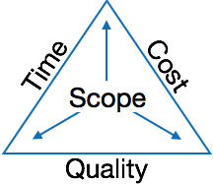

The image above shows triple constraints for software projects. It is an essential part of software organization to deliver quality product, keeping the cost within client’s budget constrain and deliver the project as per scheduled. There are several factors, both internal and external, which may impact this triple constrain triangle. Any of three factor can severely impact the other two.

Therefore, software project management is essential to incorporate user requirements along with budget and time constraints.

**Software Project Manager**

A software project manager is a person who undertakes the responsibility of executing the software project. Software project manager is thoroughly aware of all the phases of SDLC that the software would go through. Project manager may never directly involve in producing the end product but he controls and manages the activities involved in production.

A project manager closely monitors the development process, prepares and executes various plans, arranges necessary and adequate resources, maintains communication among all team members in order to address issues of cost, budget, resources, time, quality and customer satisfaction.

Let us see few responsibilities that a project manager shoulders -

**Managing People**

* Act as project leader
* Liaison with stakeholders
* Managing human resources
* Setting up reporting hierarchy etc.

**Managing Project**

* Defining and setting up project scope
* Managing project management activities
* Monitoring progress and performance
* Risk analysis at every phase
* Take necessary step to avoid or come out of problems
* Act as project spokesperson

**Software Management Activities**

Software project management comprises of a number of activities, which contains planning of project, deciding scope of software product, estimation of cost in various terms, scheduling of tasks and events, and resource management. Project management activities may include:

* **Project Planning**
* **Scope Management**
* **Project Estimation**

**Project Planning**

Software project planning is task, which is performed before the production of software actually starts. It is there for the software production but involves no concrete activity that has any direction connection with software production; rather it is a set of multiple processes, which facilitates software production. Project planning may include the following:

**Scope Management**

It defines the scope of project; this includes all the activities, process need to be done in order to make a deliverable software product. Scope management is essential because it creates boundaries of the project by clearly defining what would be done in the project and what would not be done. This makes project to contain limited and quantifiable tasks, which can easily be documented and in turn avoids cost and time overrun.

During Project Scope management, it is necessary to -

* Define the scope
* Decide its verification and control
* Divide the project into various smaller parts for ease of management.
* Verify the scope
* Control the scope by incorporating changes to the scope

**Project Estimation**

For an effective management accurate estimation of various measures is a must. With correct estimation managers can manage and control the project more efficiently and effectively.

Project estimation may involve the following:

**Software size estimation**

Software size may be estimated either in terms of KLOC (Kilo Line of Code) or by calculating number of function points in the software. Lines of code depend upon coding practices and Function points vary according to the user or software requirement.

**Effort estimation**

The managers estimate efforts in terms of personnel requirement and man-hour required to produce the software. For effort estimation software size should be known. This can either be derived by managers’ experience, organization’s historical data or software size can be converted into efforts by using some standard formulae.

**Time estimation**

Once size and efforts are estimated, the time required to produce the software can be estimated. An effort required is segregated into sub categories as per the requirement specifications and interdependency of various components of software. Software tasks are divided into smaller tasks, activities or events by Work Breakthrough Structure (WBS). The tasks are scheduled on day-to-day basis or in calendar months.

The sum of time required to complete all tasks in hours or days is the total time invested to complete the project.

**Project Estimation Techniques**

We discussed various parameters involving project estimation such as size, effort, time and cost. Project manager can estimate the listed factors using two broadly recognized techniques **Decomposition.**

**Technique**

This technique assumes the software as a product of various compositions.

There are two main models -

* **Line of Code** Estimation is done on behalf of number of line of codes in the software product.
* **Function Points** Estimation is done on behalf of number of function points in the software product.

**Empirical Estimation Technique**

This technique uses empirically derived formulae to make estimation. These formulae are based on LOC or FPs.

* **Putnam Model**

This model is made by Lawrence H. Putnam, which is based on Norden’s frequency distribution (Rayleigh curve). Putnam model maps time and efforts required with software size.

* **COCOMO**

COCOMO stands for COnstructive COst MOdel, developed by Barry W. Boehm. It divides the software product into three categories of software: organic, semi-detached and embedded.

**Project Scheduling**

Project Scheduling in a project refers to roadmap of all activities to be done with specified order and within time slot allotted to each activity. Project managers tend to define various tasks, and project milestones and they arrange them keeping various factors in mind. They look for tasks lie in critical path in the schedule, which are necessary to complete in specific manner and strictly within the time allocated. Arrangement of tasks which lies out of critical path are less likely to impact over all schedule of the project.

For scheduling a project, it is necessary to -

* Break down the project tasks into smaller, manageable form
* Find out various tasks and correlate them
* Estimate time frame required for each task
* Divide time into work-units
* Assign adequate number of work-units for each task
* Calculate total time required for the project from start to finish

**Resource management**

All elements used to develop a software product may be assumed as resource for that project.

This may include human resource, productive tools and software libraries.

The resources are available in limited quantity and stay in the organization as a pool of assets. The shortage of resources hampers the development of project and it can lag behind the schedule. Allocating extra resources increases development cost in the end. It is therefore necessary to estimate and allocate adequate resources for the project.

Resource management includes -

* Defining proper organization project by creating a project team and allocating responsibilities to each team member
* Determining resources required at a particular stage and their availability
* Manage Resources by generating resource request when they are required and deallocating them when they are no more needed.

**Project Risk Management**

Risk management involves all activities pertaining to identification, analysing and making provision for predictable and non-predictable risks in the project. Risk may include the following:

* Experienced staff leaving the project and new staff coming in.
* Change in organizational management.
* Requirement change or misinterpreting requirement.
* Under-estimation of required time and resources.
* Technological changes, environmental changes, business competition.

**Risk Management Process**

There are following activities involved in risk management process:

* **Identification -** Make note of all possible risks, which may occur in the project.
* **Categorize -** Categorize known risks into high, medium and low risk intensity as per their possible impact on the project.
* **Manage -** Analyze the probability of occurrence of risks at various phases. Make plan to avoid or face risks. Attempt to minimize their side-effects.
* **Monitor -** Closely monitor the potential risks and their early symptoms. Also monitor the effects of steps taken to mitigate or avoid them.

**Project Execution & Monitoring**

In this phase, the tasks described in project plans are executed according to their schedules.

Execution needs monitoring in order to check whether everything is going according to the plan. Monitoring is observing to check the probability of risk and taking measures to address the risk or report the status of various tasks.

These measures include -

* **Activity Monitoring -** All activities scheduled within some task can be monitored on day-to-day basis. When all activities in a task are completed, it is considered as complete.
* **Status Reports -** The reports contain status of activities and tasks completed within a given time frame, generally a week. Status can be marked as finished, pending or workin-progress etc.
* **Milestones Checklist -** Every project is divided into multiple phases where major tasks are performed (milestones) based on the phases of SDLC. This milestone checklist is prepared once every few weeks and reports the status of milestones.

**Project Communication Management**

Effective communication plays vital role in the success of a project. It bridges gaps between client and the organization, among the team members as well as other stake holders in the project such as hardware suppliers.

Communication can be oral or written. Communication management process may have the following steps:

* **Planning** - This step includes the identifications of all the stakeholders in the project and the mode of communication among them. It also considers if any additional communication facilities are required.
* **Sharing** - After determining various aspects of planning, manager focuses on sharing correct information with the correct person on correct time. This keeps every one involved the project up to date with project progress and its status.
* **Feedback** - Project managers use various measures and feedback mechanism and create status and performance reports. This mechanism ensures that input from various stakeholders is coming to the project manager as their feedback.
* **Closure** - At the end of each major event, end of a phase of SDLC or end of the project itself, administrative closure is formally announced to update every stakeholder by sending email, by distributing a hardcopy of document or by other mean of effective communication.

After closure, the team moves to next phase or project.

**Configuration Management**

Configuration management is a process of tracking and controlling the changes in software in terms of the requirements, design, functions and development of the product.

IEEE defines it as “the process of identifying and defining the items in the system, controlling the change of these items throughout their life cycle, recording and reporting the status of items and change requests, and verifying the completeness and correctness of items”.

Generally, once the SRS is finalized there is less chance of requirement of changes from user. If they occur, the changes are addressed only with prior approval of higher management, as there is a possibility of cost and time overrun.

**CHAPTER 4**

|  |
| --- |
| In the Blynk app farmer have to login to their to register with the authorized login. The authentication location have to submit with their relative field of strength. The login have to commit with the atuthorized token. The authentication token is send to the own relative id to the relative society to the end of submission. |

**PROJECT IMPLEMENTATION :-**

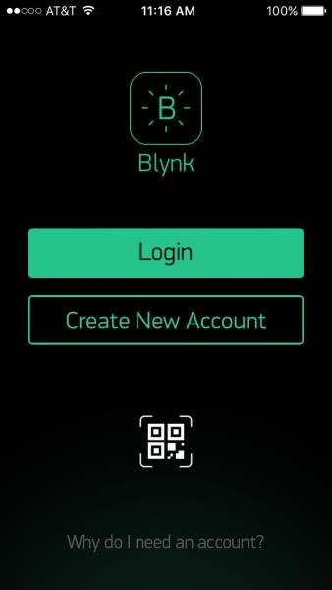

**Project Code:-**

*#include <SoftwareSerial.h>*

*SoftwareSerial SwSerial(2, 3); // RX, TX*

*#define BLYNK_PRINT SwSerial*

*#include <BlynkSimpleSerial.h>*

*// You should get Auth Token in the Blynk App.*

*// Go to the Project Settings (nut icon).*

*char auth[] = "yourAuthTokenHere";*

*Servo servo1;*

*void setup()*

*{*

*Serial.begin(9600);*

*Blynk.begin(auth);*

*// Default baud rate is 9600. You could specify it like this:*

*//Blynk.begin(auth, 57600); servo1.attach(3);*

*//pinMode(2, OUTPUT); uncomment this if you want to use virtual pins to blink the LED }*

*void loop()*

*{*

*Blynk.run();*

*}*

*BLYNK_WRITE(V1){*

*int value = param.asInt(); servo1.write(value);*

*}*

*/* BLYNK_WRITE(V2){*

*if(param.asInt() == HIGH){*

* *digitalWrite(3, HIGH);*
* *} else {*
* *digitalWrite(3, LOW);*
* *}*
* *}*

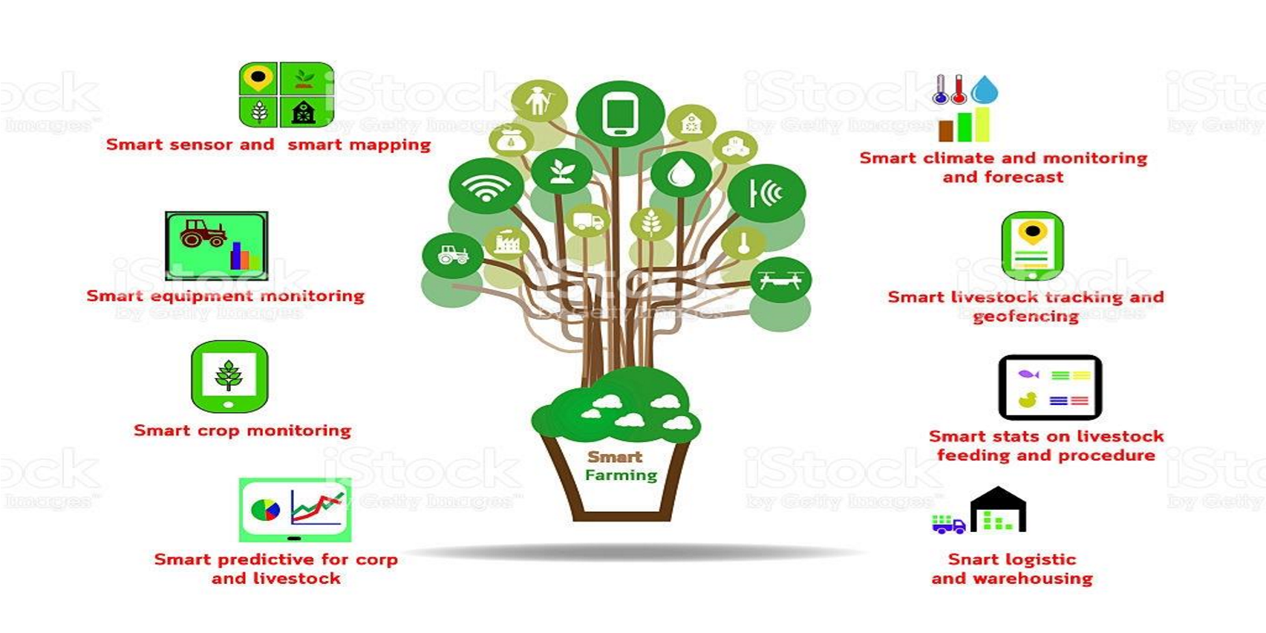

**Figure 21: Project design in sprint backlog 03**

**ERD:-**

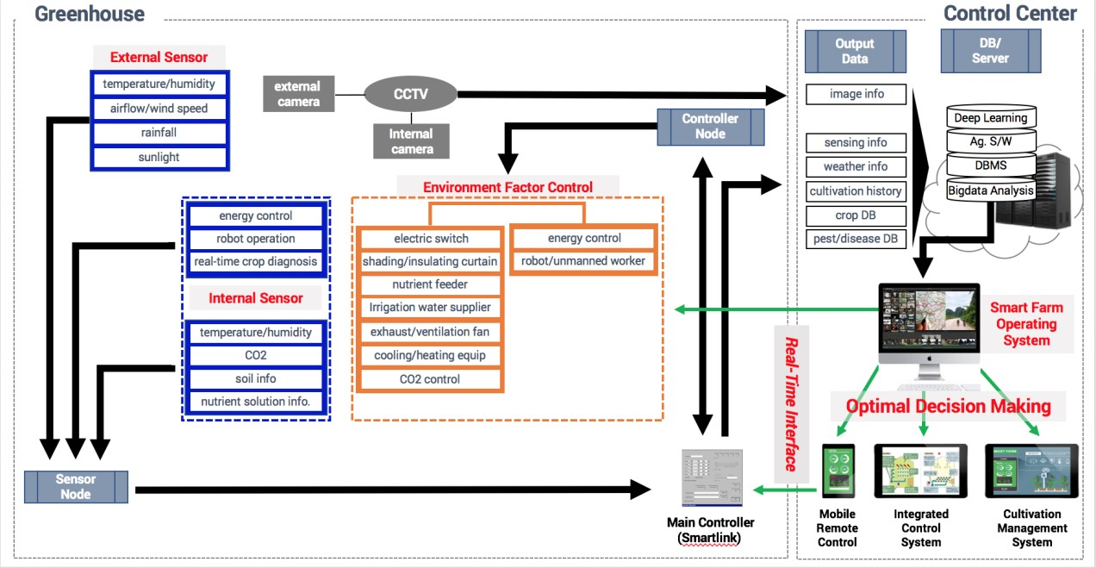

**Figure 22: ERD diagram of sprint backlog 03**

**Algorithm:-**

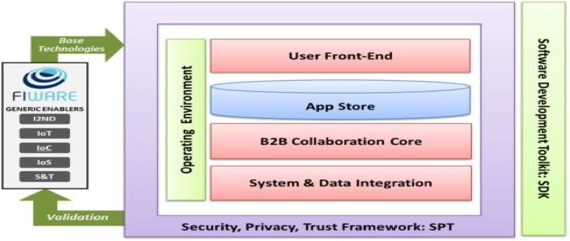

**CHAPTER 5**

**CONCLUSION**

**Results**

As agriculture sector runs in low margin, getting investments is quiet difficult. Although IoT related technology is growing, still there are some challenges in implementing IoT especially, in rural areas. Some barriers like wireless, broadband coverage are well known .Moreover there is something called “image problem”.

People still believe agriculture belong to grandfather generation so many people don’t want to come in that sector. Another challenge can be the question “who will be the owner of those sensor controller data? Data on soil or water could be used by biotech giants. Access to real time info about harvesting helps corporation predict property value of farmers to get idea about market. However IoT should be brought closer to primary sector by integrating with complementary tools to generate more efficient product.

Electronic media can help in this regard by advertising commercials and on air campaigns about new technologies. The information from one farm can be shared with other farm in order to get aggregated output.

The smart irrigation system was tested on a garden plant. The plant’s water requirement is

600-800mm a day and temperature requirement of the soil ranges from 50oC- 100oC. In the Arduino code, the moisture and temperature range were set as 300-700 and 450-800 respectively (which delineates the corresponding resistance value in digital format). Moreover this system proves to be cost effective and proficient in conserving water and reducing its wastage.

**Conclusion**

Although IoT in agriculture is in nascent stage in India still the way we are embracing technologies we can be hopeful. If farmers are provided with proper training about technologies, with a smart mobile in hand they can perform many of their agricultural tasks without even reaching there.

Basically it helps farmers to stay connected with their farms from anyplace anytime. It also helps in reducing human effort with increased productivity and at the same time it boosts economy of farmers. Therefore with fully equipped software and Internet of Things, agriculture industry can provide a better vision for next generation and make India better in coming days.

**Future Scope**

IoT is not just a technology but an ecosystem of technologies or amalgamation of different sets of technology that can have a profound impact on our lives – personal, professional and social. With respect to agriculture, IoT devices provide precise information on a wide range of parameters that are required for enhancing farming methods and cultivation of fresh produce. These include environmental factors, growth conditions, soil, farming equipment , greenhouse production environment , water irrigation, pest and fertilizers .

WSN helps in real-time monitoring and management. The initiative Digital India taken by our current Prime Minister should reach rural people more. It is therefore, heart rendering that the government of India has recognized it and in some ways laid down the vision for the digital rural India through Smart Agriculture. ‘Financial Inclusion’ and ‘IoT for Agriculture’ can be the two pillars to kick-start the journey of rural India towards socio-economic equality.

It is now upon the private sector and start-up communities to bring innovations that can help realize these dreams. There are many companies like Onfarm, Farmobile, CropX, Farmx and Farmlogs are working towards smart farming.

The ongoing research in the field of IoT and its implementation in full or partial manner will definitely improve the quality of life of human civilization .Today IOT is being implemented everywhere which is of human concern like Smart city, smart environment, security and emergencies, smart business process, smart agriculture, domestic and home automation and healthcare.

Search engine giant Google has already taken initiatives to mark its presence in the field of IoT. It is trying to transform the IoT by putting their enthral concept of making the physical URL as future of IoT instead of apps which we commonly use. In this process, the browser will display a beacon style broadcast in which the nearby object will appear which will be present in the near proximity and can be communicated directly with the help of URL’s according to the preference of users and signal strength of the smart object.

On the other hand IBM and Libelium has launched 6LoWPAN development platform for IoT which will enable every single sensor and devices to connect directly to the Internet using the new IPv6 protocols. China and many European countries are investing high amount of their GDP in making smart architectural infrastructure for e.g. Smart Roads and Bridges for the safety of people. In this smart bridges if corrosion or if any malfunction happens it will communicate directly so that repair work can be done at the proper time. Smart agriculture is also in research, Waspmote has taken this initiative for optimum productivity using the sensor networks to maintain monitoring capacity of crop cultivation.